# **Money Credit and Withdrawal Backend System**

1. **Project Setup**
   1. Visual studio
   2. Python environment
   3. Project repository creation in GitHub
   4. Project setup in local

**1.1. Project Repository Creation in GitHub**

Step 1: create GitHub account, login to your account then go to `your profile` option and click on the ` new button` to create a new repository

Then give the Repository name `your repository name`

Check the Add a README file option as shown below

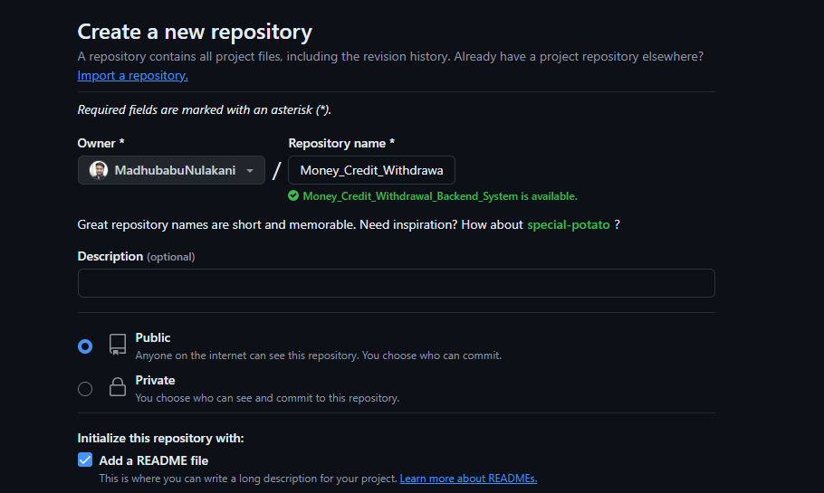

After there is a one button ‘create repository’ click on that it will creates the new repo for your project

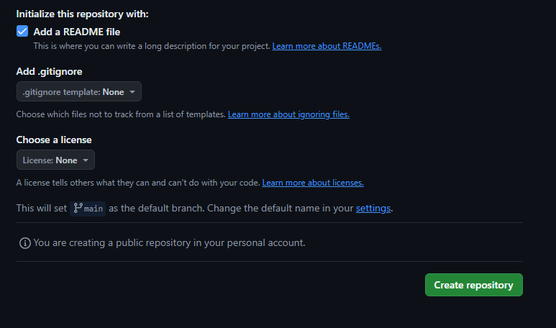

After created the new repository to your project it seems like below

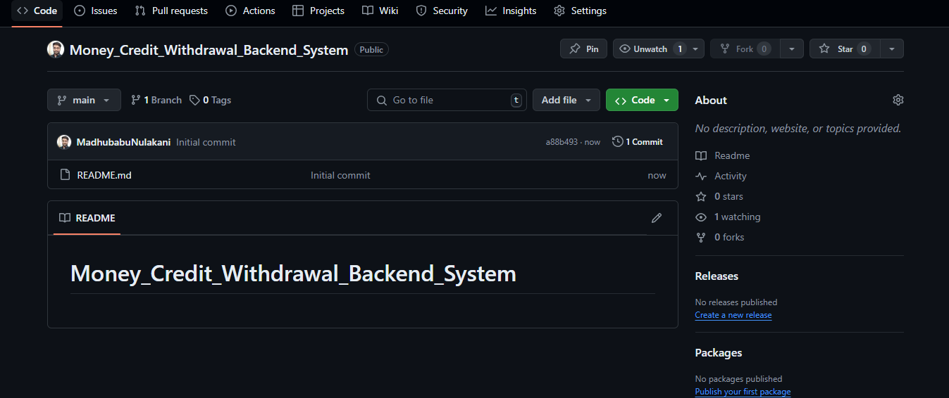

* 1. **. Project Setup in Local**

**Step 1**: Create a folder (workspace) in local system to maintain the git repository

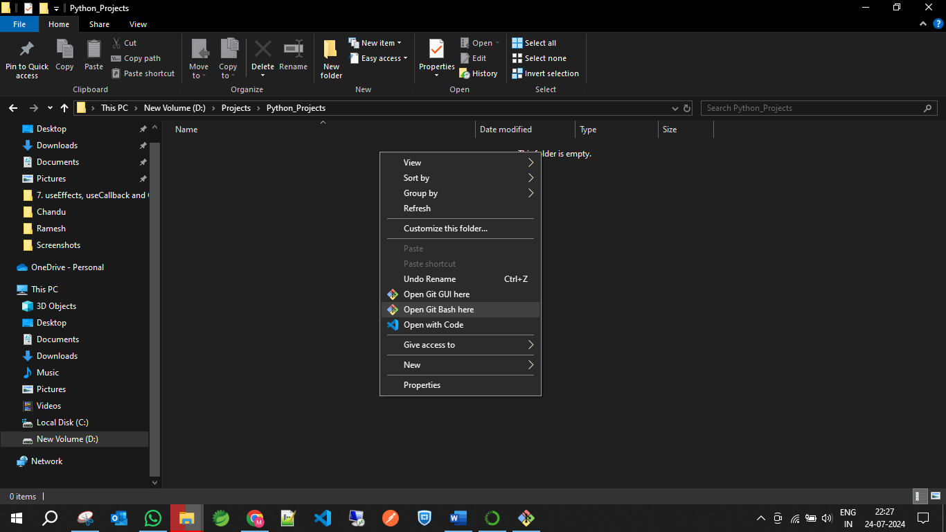

**Step 2:** open the git bash in your local workspace -> it’s look like below

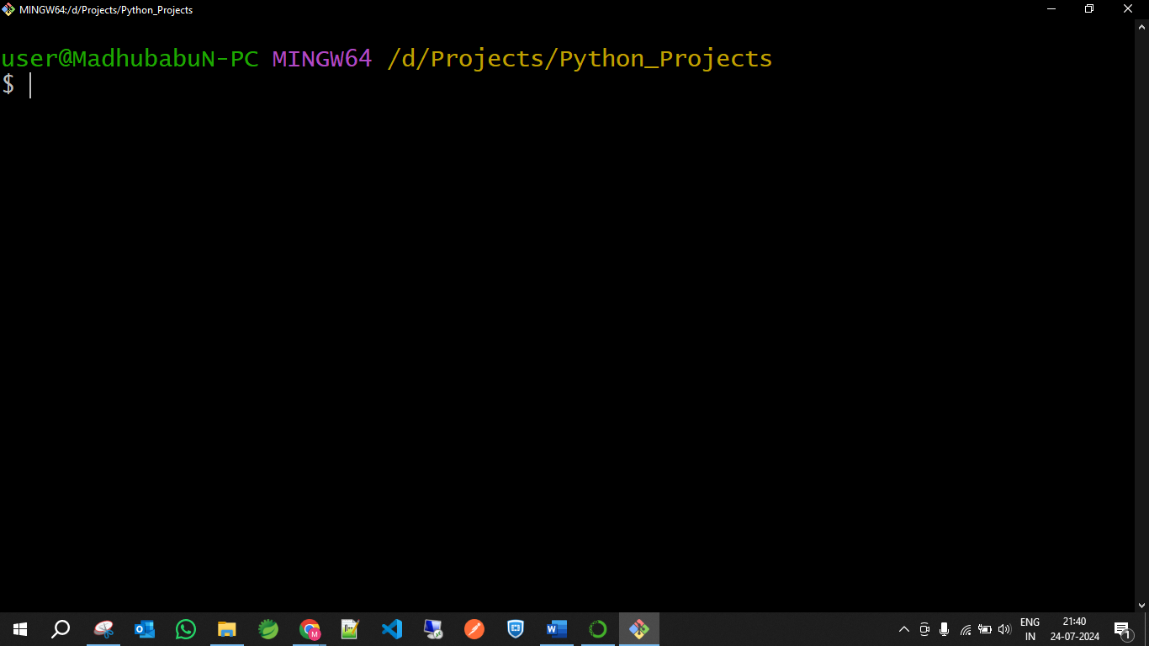

**Step 3:** Open your repository in GitHub, click on the code button it seems like below

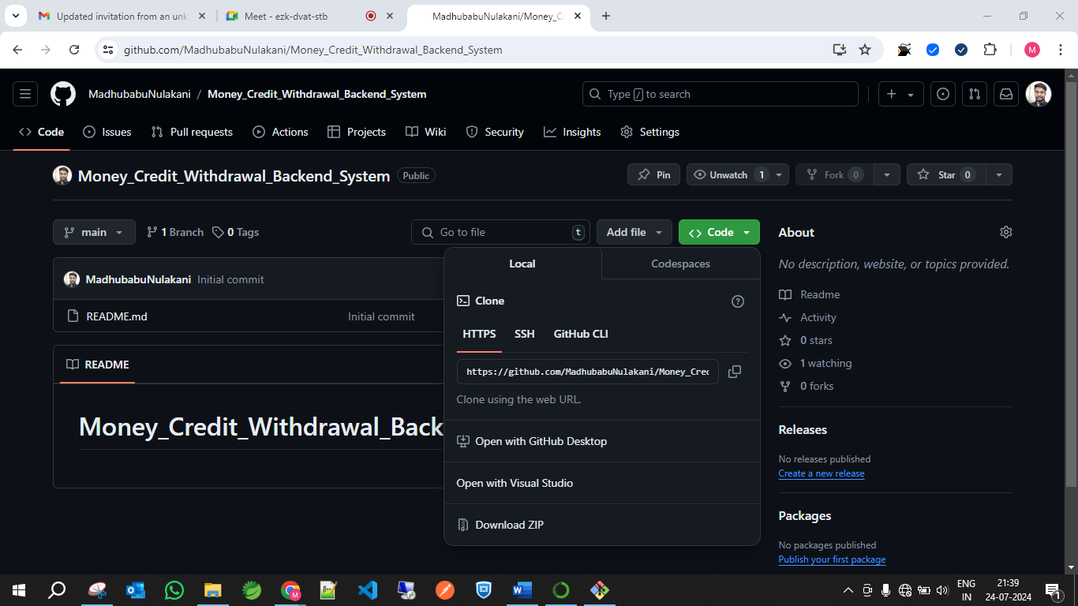

**Step 4:** Select the Https the copy the URL and run the below command in git bash, this command will create your GitHub repo in local

|  |
| --- |
| **$ git clone < your_git_repo_url >** |

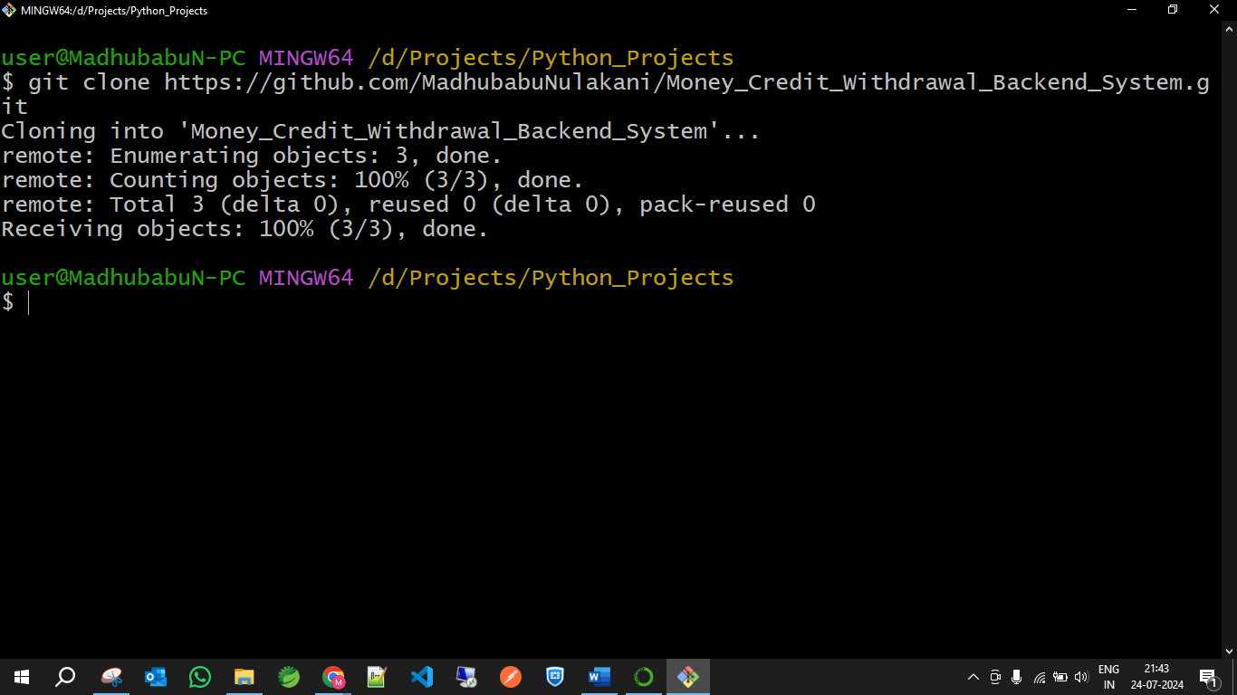

**Step 4:** After cloned the repo, open your project in ‘ VS code’ editor as shown below

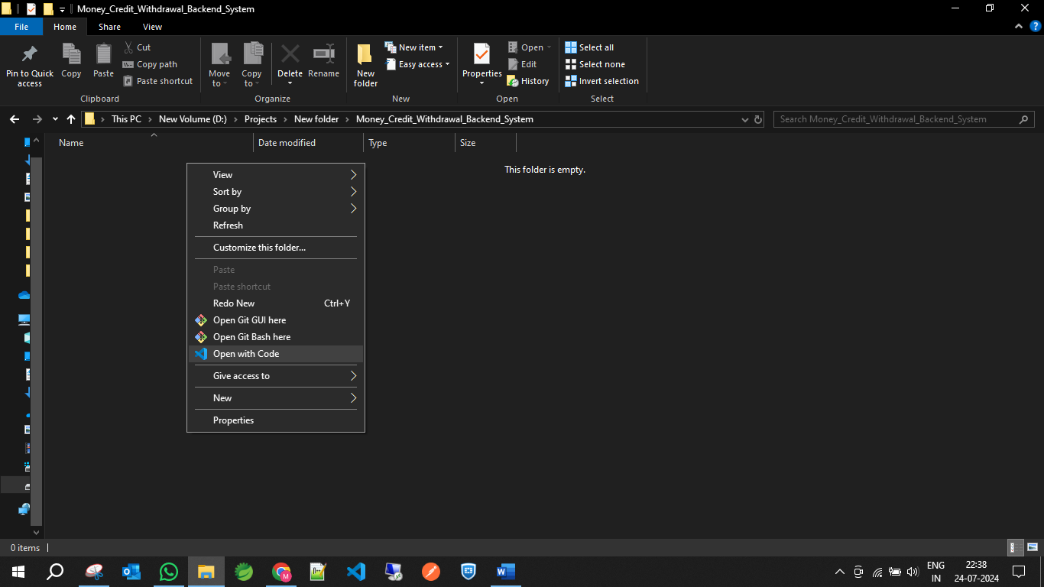

**Step 5:** After opened the project in vs code, create the file to maintain the structure of the project

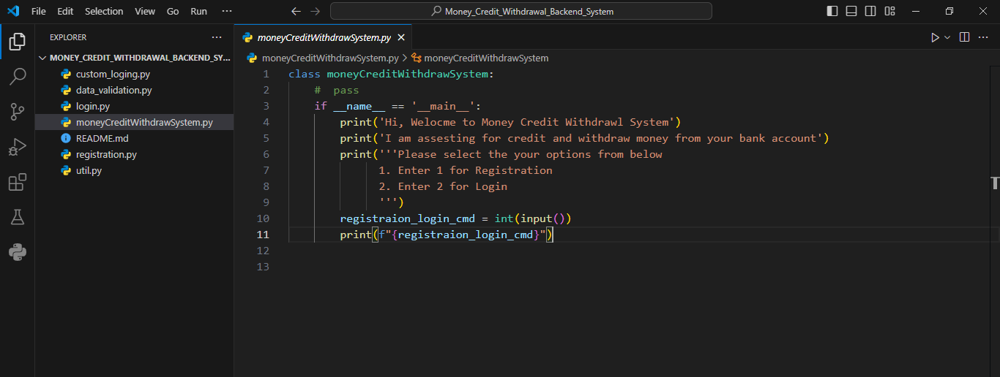

After that push the all changes into your repository